MIG200M Manual

1. GENERAL
Commissioning and operation of the device can be made only after a careful reading this User manual. Due to the continuous development of technical equipment, some of its functions can be modified and effect may vary slightly from the descriptions in the manual. This is not a device error, but the results progress and continuous modification work unit.
Damage to the unit due to improper use will void the warranty. Any alteration of the rectifier are prohibited and void the warranty.
2. SAFETY
Staff operating the device should have the necessary qualifications entitling them to welding work:
• should be empowered electric welder in the field of gas-shielded welding,
• know the safety rules during the operation of the power they are welding and auxiliary equipment powered by electricity,
• know the safety rules when handling cylinders and installation of compressed gas (argon)
• familiar with the contents of this manual and use the device for its intended purpose.
WARNING
Welding may endanger the safety of the operator and other persons in the vicinity. Therefore, when welding special precautions must be taken. Before welding refer to the applicable health and safety regulations in the workplace.
During electric arc welding method MMA and MIG / MAG are the following hazards:
• ELECTRIC SHOCK
• NEGATIVE IMPACT OF CURVE TO EYES AND SKIN OF MAN
• PAIRS AND GAS POISONING
• BURNS
• RISK OF EXPLOSION AND FIRE
• NOISE
Preventing electric shock:
• connect the device technically efficient electrical installation of the proper safeguarding and the effectiveness of neutral (extra shock protection); Check and correct connect to a network other devices in the workplace welder,
• Current wires installed with the unit off,
• Do not touch uninsulated portion of the handle at the same time the electrode, the electrode and the object welded, in this enclosure,
• Do not use the handles and load wires with damaged insulation,
• the conditions of special risk of electric shock (work environments high humidity and closed tanks) to work with the helper supporting the work of the welder, and watchful over security used clothing and gloves with good insulation
• if you notice any irregularities, please contact the competent people to remove them,
• It is forbidden to operate the device with the covers removed.

Preventing negative effects of electric arc on human skin and eyes:
• Wear protective clothing (gloves, apron, boots, leather)
• Use protective shields or helmets with properly matched filter,
• Use protective curtains of non-combustible materials and properly choose the color of the walls absorbing harmful radiation.

Poisoning prevention vapors and gases are secreted during the welding electrodes and coatings
Evaporation of metals:
• Use ventilation and exhaust installed in limited exchange air
• blow fresh air when working in a confined space (tanks)
• Use masks and respirators.
Preventing burns:
• Wear appropriate protective clothing and shoes to protect from burns coming from arc radiation and spatter,
• Avoid contamination of clothing lubricants and oils that may lead to its inflammation.
Explosion prevention and fire:
• Do not use the machine and welding in hazardous or fire
• Position welding should be equipped with fire-fighting equipment,
• Welding position should be at a safe distance from flammable materials.
Preventing the negative impact of noise:
• Use earplugs or other hearing protection.
• Warn about the danger of people in the vicinity.

WARNING!
Do not use the power source for thawing frozen pipes.
Before starting the unit:
• Check electrical connections and mechanical. It is forbidden to use the brackets and wires current with damaged insulation. Inadequate insulation handles and cables current danger electric shock,
• Ensure proper working conditions, ie. To ensure proper temperature, humidity and ventilation in place work. Out of doors to protect against precipitation,
• Place the charger in a place that allows its easy handling.

Persons operating welder should:
• have the power to electric welding MMA and MIG / MAG,
• know and comply with health and safety regulations in force in carrying out welding work,
• Use the proper, specialized protective equipment: gloves, apron, rubber boots, shield or a welding helmet with a suitably selected filter,
• familiar with the contents of this manual and operate welder in accordance with its intended purpose.

Repair work may only be carried out after removing the plug from the socket power.
When the device is connected to a network is not allowed to touch the bare hand or by wet clothing
any circuit elements forming the welding current. It is forbidden to remove the outer casing when the device is on the network. Any alteration of the rectifier on its own is prohibited and may be worsening safety conditions.

All maintenance and repair may only be carried out by authorized persons from under safe conditions of work applicable to electrical appliances.
It is forbidden to use a welder in explosive or fire!
Welding station should be equipped with a fire-fighting equipment.
After working the power cord appliance should be disconnected from the network.
The above risks and the general safety rules is not exhaustive safety welder, because it does not take into account the specifics of the workplace. An important they are complemented by bench safety instructions, training and briefings given by the supervisors.
3. GENERAL DESCRIPTION
Welding semi-automatic MIG 200M is used for manual welding of steel and non-ferrous metals method MMA (coated electrode) and MIG / MAG gas-shielded or self-shielded wire without the use of protective gases. It can be used also for braze welding of thin (3mm) sheet galvanized. It can be used indoors or covered, unexposed direct effects of the weather. Works with coils of wire D200 (5kg).
Option MIG / MAG handle Spool Gun (SG) enables parallel connection of the second bracket type SG is mounted at the mini wire feeder and reel D100 steel wire or color, thanks you can weld two different wire welding without retooling. Selecting the handle followed by the mode switch. It is a time-saving solution for the need for the welding of different materials, or of occasional use of different wire diameters.

4. SPECIFICATIONS

4.1 Welder
Supply voltage: 230V AC 50Hz
Rated welding current / cycle 200 A (MIG); 185 A (MMA) / 60%
Range of welding current 30-200 A (MIG); 17-185 A (MMA)
Maximum welding current to handle Spool Gun 130 A
The diameter of the wire reel: 200 mm
The adjustment range wire feed speed 1,5-19 m / min
Maximum current consumption / power 37.4 A / 8.8 kVA
Weight: 21 kg
Dimensions: 500 x 260 x 540 mm
Degree of protection IP21

4.2 MIG
Handle Type TW-15
The maximum current carrying capacity 200 A
Type of cooling Gas shielding
The cooling gas flow 10-18 L / min
Length 3 m

4.3 Handle Spool Gun (optional)
Handle Type Spool Gun 15 (MTMSG3M)
The maximum current carrying capacity 150 A
Recommended diameter welding wire 0.6-1.0 mm
Wire feed speed 1-13 m / min
Length 3 m

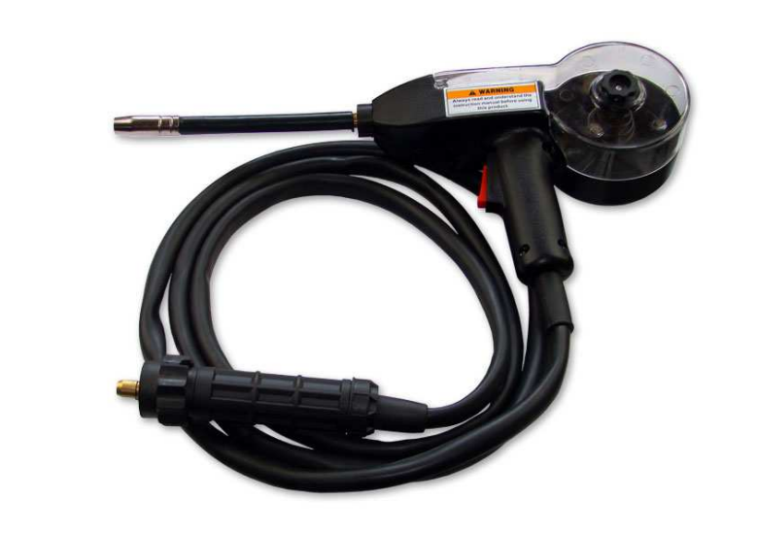

Duty cycle
Duty cycle is based on a period of 10 minutes. The duty cycle of 60% means that after 6 minutes of operation. It is required 4-minute break. The duty cycle of 100% means that the device can operate in a way continuously without interruption.
Warning! Heating test was carried out in the ambient air temperature. Duty cycle at 40 ° C was determined by simulation.
Security Level

IP specifies the extent to which the device is resistant to entering of impurities solid and water. IP21 means that the unit is suitable for indoor closed and is not suitable for use on rain and snow.
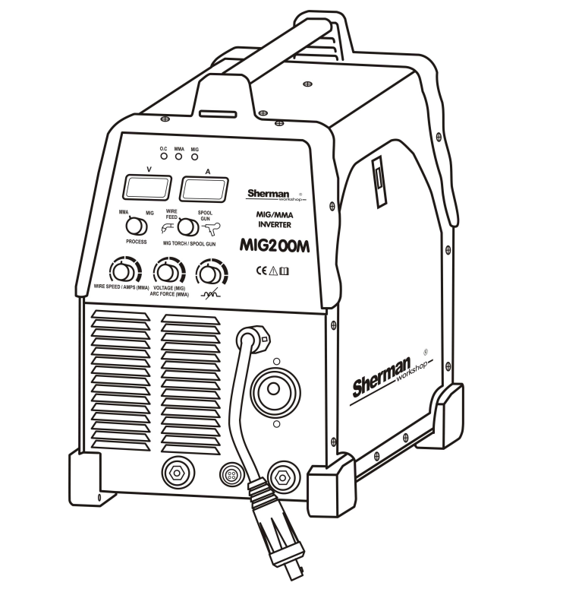
5. PREPARATION OF THE DEVICE TO WORK

5.1 CONNECTION shielding gas
1. Attach the bottle and secure it against tipping.
2. Remove the cylinder valve briefly to remove any impurities.
3. Install the regulator on the cylinder.
4. Connect the hose from the regulator welder.
5. Remove the cylinder valve and regulator.

5.2 CONNECTION TO THE MAINS
1. The unit MIG 200M to be used only in a single-phase power, three-wire with grounded star.
2. Semi-automatic MIG welding 200M is compatible with the network 230V 50Hz 32A fuse protected by delayed action.
3. The device is equipped with a cord and plug the power cord. Before connecting power, make sure the power switch located on the rear panel is in the OFF position (Off).
5.3 Setting a spoil with wire.
1. Open the side cover of the housing.
2. Verify that the drive rollers are suitable for the type and diameter of the wire.
3. Place the spool of wire electrode on the stem.
4. Secure the spool from falling.
5. Release the pressure feed rollers.
6. Blunt end of the electrode wire.
7. Enter the wire drive roller via the tray to the holder.
8. Push the wire into the grooves of the drive roller.
9. Remove the handle end of the current, turn the power equipment and the button QUICK FEED (17)
located within the chamber and enter the wire spool holder.
10. When you see the electrode wire in the outlet handle release button and shoot tip current.

5.4 PREPARING THE HANDLE MIG TO WORK
Depending on the type of material being welded and the filler wire diameter to establish a MIG relevant product contact tip and the contribution of lead wire. For steel welding tips used for welding current and the contribution of steel. In case of aluminum welding tip to apply current to weld aluminum and the contribution of Teflon:

The diameter of the electrode wire | Diameter of the contact tip | Contribution leading wire
0.8 | 0.8 | Blue
1.0 | 1.0 | Blue/Red
1.2 | 1.2 | Red
1.6 | 1.6 | Yellow

6. DESCRIPTION OF THE FUNCTION SWITCH AND DIAL

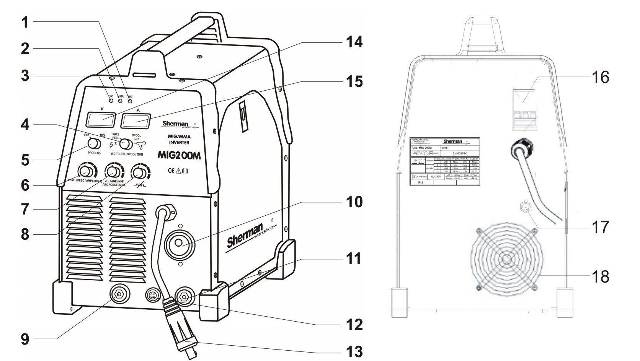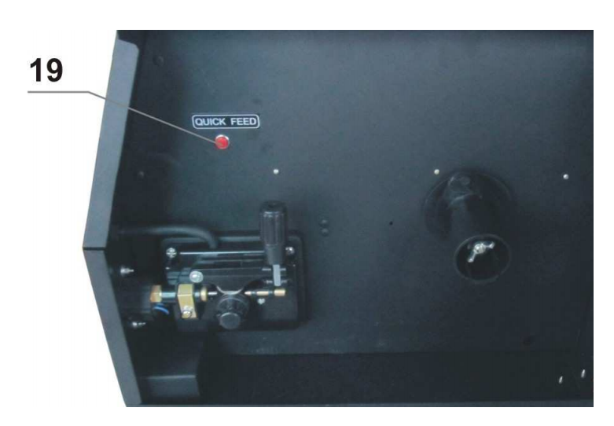

1. LED indicates choice of MIG.
2. LED indicates choice of MMA.
3. LED thermal protection.
4. Switch MIG / handle Spool Gun.
5. Switch welding method (MMA / MIG).
6. Welding current regulator (method MMA) or the wire feed speed (MIG).
7. Knob welding voltage (MIG) or the ARC FORCE, (MMA method).
8. Knob inductance.
9. Jack negative polarity.
10. Jack MIG.
11. Slot positive polarity.
12. Control plug handle Spool Gun.
13. The connector polarity switch (for MIG).
14. Display of welding voltage
15. Display of welding current
16. Power switch.
17. Discharge gas.
18. Fan
19. The start button feeder QUICK FEED.

ARC FORCE
ARC FORCE allows you to adjust the dynamics of the arc. Shortening the length of the arc accompanied by an increase of the welding current, thus stabilizing the arc. Reducing the value of the function gives the curve soft and less depth of penetration, while increasing the value of the function results in deeper penetration and the possibility of short-arc welding. When you set a high value features ARC FORCE can be welded maintaining the minimum arc length and a high melting rate of the electrode.
Adjusting the inductance (reluctance arc)
Adjusting the inductance of the arc can be optimized depending on the thickness of the welded element method and the conditions of welding. This function is useful when MIG / MAG thin elements, preventing them from burnout and braze welding galvanized elements. The thinner element welded meth MIG / MAG the inductance should be higher (soft arc - lower penetration) for heavy elements vice versa (arc hard - greater penetration). Standard, neutral setting Inductance is in the middle of the scale. Changing inductance value also influences the reduction the amount of spatter welding in CO2 shield. The optimum setting values inductance depends on several factors and may deviate from the standard recommendations must be chosen during rehearsals welding manipulating knob potentiometer. Adjustment of this parameter allows the brazing of thin (3 mm) galvanized elements wires made of copper alloy CuSi3 (available from TECWELD) shielding mixture of Ar / CO2 20/80%. In this case we proceed conversely, setting the low inductance for low currents braze welding.

7. Protection against overheating.
The power source is equipped with a thermal, a circuit breaker. when the temperature of welding is too high, safety disconnects the welding current and the LED indicator lights overheating (3). After falling temperature will automatically reset the breaker.

8. PREPARATION FOR WELDING PROCESS
8.1 METHOD MMA
8.1.1 Preparation for operation
1. Make sure the power switch located on the rear panel is in the OFF position (Off)
2. Clamp tongs ground cable firmly affixed to the weld material.
3. Place the electrode wires and the mass of the sockets (+) and (-) welding so that the electrode holder was appropriate for the electrode pole. Polarity Wiring depends on the type of welding electrodes are used, and is supplied to the electrode packaging.
4. Turn on the power.

8.1.2 Setting the welding parameters
1. Set the method of welding (5) to position MMA.
2. Turn (6) set the welding current.
3. knob (7) to set the appropriate value of the ARC FORCE function.

8.1.3 Arc Initiation
1. Touch the electrode to the workpiece, briefly rub and tear.
2. In the case of initiation of the arc electrode, which forms a cover of non-conductive when solidified slag. pre-clean the tip of the electrode by repeated impact on a hard surface until you get the metallic contact with the work piece.

8.2 METHOD FOR MIG / MAG AND brazing
8.2.1 Preparation for operation
8.2.1.1 Welding and brazing gas-shielded
8.2.1.1.1 Welding handle traditional
1. Make sure the power switch (16) on the rear panel is in the OFF position (off).
2. Insert the spool with the appropriate wire electrode.
3. Connect the cylinder with the appropriate shielding gas to the nozzle (17).
4. Clamp tongs ground cable firmly affixed to the weld material.
5. The second end of the mass in the socket (-) welding.
6. Plug the welding torch in the socket (10) and tighten the nut.
7. Plug polarity switch in the socket (+) welding.
8. Switch (4) to position WIRE FEED.

8.2.1.1.2 Welding handle type Spool Gun (optional)
1. Make sure the power switch (16) on the rear panel is in the OFF position (off).
2. Connect a cylinder of shielding gas to the nozzle (17).
3. Clamp tongs ground cable firmly affixed to the weld material.
4. The other end of the mass in the socket (-) welding.
5. Plug the handle Spool Gun in the socket (10) and tighten the nut.
6. Place the spool of wire to handle Spool Gun.
7. Plug polarity switch in the socket (+) welding.
8. Plug control handle in the socket (12).
9. Switch (4) to position SPOOL GUN.
Warning! Handle Spool Gun is designed for welding thin metal wire 0,6-1,0mm. Maximum welding current for this handle has been electronically limited to 130A.

8.2.1.2 Welding steel wire self-shielded
8.2.1.2.1 Welding handle traditional
1. Make sure the power switch (16) on the rear panel is in the OFF position (off).
2. Place the spool of self-shielded wire.
3. Clamp tongs ground cable firmly affixed to the weld material.
4. The other end of the mass in the socket (+) welding.
5. Plug the welding torch in the socket Euro and tighten the nut.
6. Plug polarity switch in the socket (-) welding.
7. Switch (4) to position WIRE FEED.
8.2.1.2.2 Welding handle type Spool Gun (optional)
1. Make sure the power switch (16) on the rear panel is in the OFF position (off).
2. Clamp tongs ground cable firmly affixed to the weld material.
3. The other end of the mass in the socket (+) welding.
4. Insert the handle Spool Gun in the socket (10) and tighten the nut.
5. Place the spool of wire to handle Spool Gun.
6. Plug polarity switch in the socket (-) welding.
7. Plug control handle in the socket (12).
8. Switch (4) to position SPOOL GUN.

8.2.2 Setting the parameters of welding and braze welding
1. Turn on the power supply connector on the rear panel of the unit.
2. Set the welding method (5) to position MIG / MAG.
3. knob (7) set the appropriate welding voltage.
4. knob (6) Set the wire feed speed.
5. knob (8) to set the appropriate inductance (see point 6).

8.2.3 Arc Initiation
1. Bring the handle to be welded, so that the distance between the nozzle and welded parts was approx. 10 mm.
2. Press the button on the torch and start welding. Releasing the end welding process

10. OPERATING INSTRUCTIONS
Operation semi-automatic MIG welding 200M should take place in an atmosphere free from ingredients corrosive and dusty. Do not place the device in dusty, near the working grinders etc. Dust and pollution filings metallic control boards, wiring and connections between components may lead to short circuit and, consequently, the damage to the welder.
Avoid use in humid environments, and particularly in situations the occurrence of dew on the metal parts. In the case of metal components on the Dew example. After the cold equipment a warm room, wait until it is completely dry and heating equipment ambient temperature. Starting in these conditions, cold welding may cause damage. It is recommended that when operating the welder by placing it outdoors under a roof into protect against adverse weather conditions.
MIG 200M should be operated under the following conditions:
- Changes in the effective value of the supply voltage of no more than 10%
- The temperature range -10 ° C to + 40 ° C
- Atmospheric pressure 860 to 1060 hPa
- Relative humidity of ambient air not more than 80%
- Height above sea level to 1000m

11. INSTRUCTIONS FOR MAINTENANCE
As part of the everyday operation of the welder must be kept clean and check the status of the holder, wires and external connections.
Regularly replace consumables. Periodically clean the inside of the device through the blow with compressed air to remove dust and metal filings from the control boards and wires and electrical connections. No less than once every six months should be a general review and the status of the electrical connections and, specifically:
- State of shock protection
- Insulation condition
- The state of security
- Correct operation of the cooling system

12. Electrical Scheme

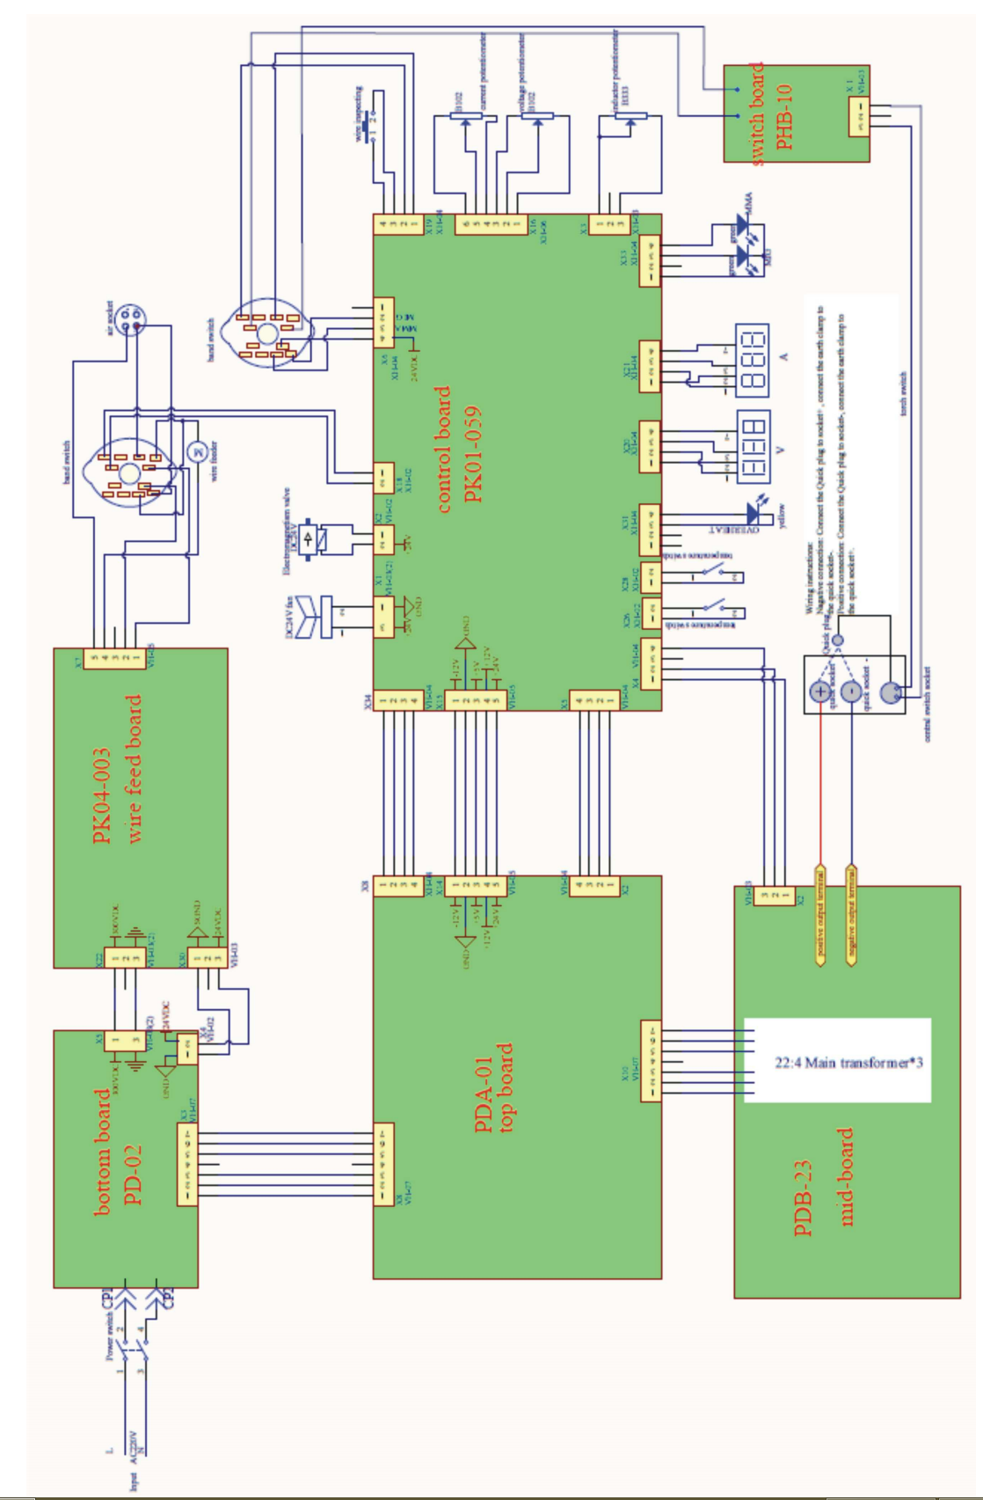
13. INSTRUCTIONS FOR STORAGE AND TRANSPORT
The device should be stored at -10 ° C to + 40 ° C and relative humidity up to 80% free from corrosive fumes and dust. Transportation of packaged devices should be covered means transport. When transporting wrapped protect the device from moving and provide them with the correct position.
14. SPECIFICATIONS SET
1. Source 1 pc.
2. The welding 1 unit.
3. Earth cable with a clamp 1 pc.
4. Wire electrode 1 pc.
5. Gas hose, brush and hammer welding shield 1 set.
6. Manual 1 pc.
7. Packaging 1 pc.

